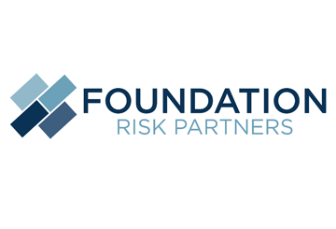
2022 OSHA Penalty Amounts
Key Points
Annual Updates
OSHA must adjust its civil penalty amounts for inflation each year.
Possible Penalties
OSHA may assess these penalties on employers that violate workplace safety and health standards set by the OSH Act.
Compliance Review
Employers should review their compliance with OSHA regulations to minimize potential liability.

The Department of Labor (DOL) has released its 2022 inflation-adjusted civil monetary penalties that may be assessed on employers for violations of a wide range of federal laws, including the Occupational Safety and Health Act (OSH Act). The increased amounts apply to civil penalties that are assessed on or after Jan. 15, 2022.
Violation Type | 2021 | 2022
Posting requirement | Up to $13,653 for each violation | Up to $14,502 for each violation
Other-than-serious violation | Up to $13,653 for each violation | Up to $14,502 for each violation
Serious violation | Up to $13,653 for each violation | Up to $14,502 for each violation
Willful violation | Between $9,753 and $136,532 per violation | Between $10,360 and $145,027 per violation
Uncorrected violation | Up to $13,563 per day until the violation is corrected | Up to $14,502 per day until the violation is corrected
Employers should become familiar with the new penalty amounts and review their safety protocols to ensure compliance with federal requirements.
The increased amounts apply to civil penalties that are assessed on or after Jan. 15, 2022.
Provided to you by Foundation Risk Partners

